
WEB DEVELOPMENT
WEDE5020 [POE]
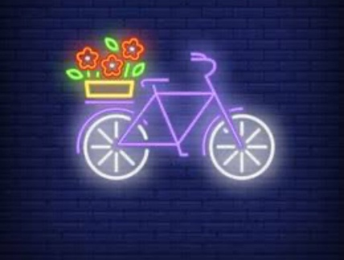
APRIL 7, 2026
LAVEKO NGOBENI
ST10472961, GROUP 3

Table of Contents
Overview of the Organization 3
A short history of Neon Cycle 3
Website Goals and Objectives 4
Key Performance Indicators (KPIs) 4
Current Website Analysis 4
Proposed Website Features and Functionality 5
Design and User Experience 8
Colour Scheme: 8
Layout and design 8
User Experience Factors 9
Wireframes with low fidelity (described): 9
Technical Requirements 9
Timeline and Milestones 9
BUDGET 10
References 10

Overview of the Organization
Name: Neon Cycle
Logo:


A short history of Neon Cycle
began in 2020 as a mobile bike repair service in the CBD of Cape Town. The owner opened a real store in Woodstock in 2023 because there was a growing demand for commuter bikes and eco-friendly transportation. The store sells new and used bikes, bike parts, and offers repair services.

Mission Statement: To make biking easy, cheap, and safe for people who live in cities and to encourage eco-friendly transportation.

Vision statement: By 2030, we want to be the most trusted place in Cape Town to buy and fix bicycles.

Target audience
People who live in the city and commute to work between the ages of 20 and 45, university students, fitness enthusiasts, and people who care about the environment. Income levels: from lower-middle to upper-middle.

Website Goals and Objectives
· Get 3,000 unique visitors to your website each month in your area to raise brand awareness.
· Get people to ask about your services and prod ucts. Aim for 30 inquiry form submissions every week.
. Cut down on phone calls and walk-ins for basic information by moving half of the usual questions to the website's FAQ and contact form.
. Make sure that at least 60% of visitors see the product and service pages, and clearly show bicycle models and repair prices.

Key Performance Indicators (KPIs)
. Unique visitors per month (Google Analytics)
. Number of times the inquiry form was filled out
. The bounce rate on product pages should be less than 40%
. Time between submitting a contact form and getting a response (within 24 hours)

Current Website Analysis
There is no website for Neon Cycle right now. The business depends on posts on Instagram and word of mouth

Weaknesses of the current state of affairs:
. There is no main list of bikes or bike parts.
. Customers can't see how much repairs will cost or book them online
. Questions get lost in Instagram DMs
. No way to get feedback from customers or sign up for the newsletter

The new website has made things better:

. A full list of products with pictures, descriptions, and prices
. Form for booking services online.
. A contact page with a map of the store's location and hours.
. Form for asking about special orders and group buys.

Proposed Website Features and Functionality
Homepage (index.html)
. A picture of a cyclist riding through the city as a hero image.
. A short welcome message and buttons that say, "Shop Bikes" and "Book a Repair."
. Featured items (the three best-selling bikes).
. A navigation menu that links to all pages.

About us
. The history of the neon cycle.
. Mission and vision statements.
. Profiles of the team members (the owner and two mechanics).
. Pictures of the workshop.
And an image of the to show one of the services we offer
Image 1:
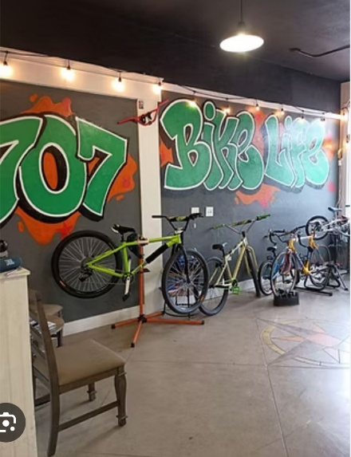
(gates , 2026)

Products
. Bicycles per category (commuter, mountain, electric, kids) are displayed in a grid style.
. Every product has a picture, a brief description, a price, and a "Enquire Now" button.
. JavaScript-based search and filter capabilities (by category or price).
Image 2:

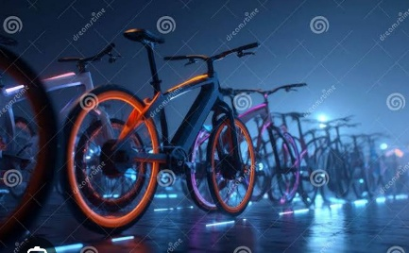
(stocktake, 2026)

Image 3

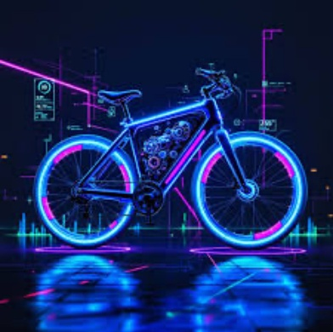
(igorvetushko, 2026)

Enquiry
. form for scheduling repairs and product inquiries.
. Complete name, phone number, email address, inquiry type (product, repair, or other), and message are all fields.
. Client-side validation (phone number length, valid email format, mandatory fields).
. Following validation, an anticipated repair turnaround time or product availability is shown in a response message.
Image 4

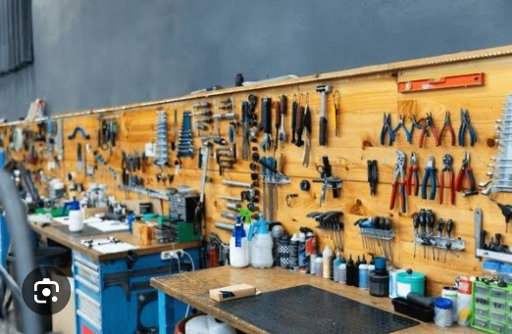
(Getty , 2026)
This image shows the workshop

Our Values
. Affordability: We provide payment options for new bikes and maintain reasonable costs.
. Reliability: A free 30-day recheck is included with every repair.
. Community: We provide free group rides and workshops on basic maintenance on Saturdays.
. sustainability: We sell donated bikes at half price after refurbishing them.
Image 5
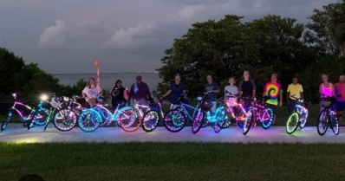
(Getty, 2026)

Image 6
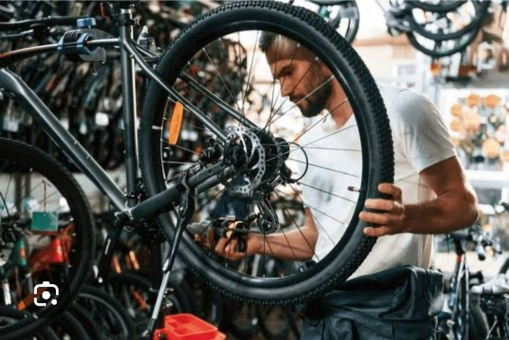
(IgorVetushko, 2026)
This image shows repairing a wheel

Contact
.Address of the store (Woodstock, Cape Town).
. The store and an additional satellite service station (Observatory) are two embedded Google Map sites.
. For general messages, use the contact form (name, email, subject, message).
. phone number and hours of operation.
Extra features (Part 3):
. JavaScript image gallery including a lightbox for pictures of bicycles.
. The contact page has an Accordion FAQ section.
. dynamic filter for product searches.

Design and User Experience
Colour Scheme:
. Primary: Deep blue (#0A2F44) stands for dependability and trust.
. Secondary: Neon yellow (#E5FF00) for accents, buttons, and hover effects.
. Background: For contrast, use light grey (#F4F4F4).
. Text: For ease of reading, choose dark grey (#222222).
Typography
. Poppins (semi-bold) is the heading.
. Open Sans (normal) is used for body text.
. H1 (2.2rem), H2 (1.8rem), H3 (1.4rem), and body (1rem) make up the hierarchy.

Layout and design
. Simple, contemporary, and minimalist.
. Flexbox is used for product cards, whereas CSS Grid is used for overall layout.
. lots of white space to draw attention to product photos.

User Experience Factors
. Easy access using a sticky navigation menu.
. Mobile-first design: three columns on a desktop, two columns on a tablet, and one column on a phone.
. large touchscreen buttons that can be tapped.
. On forms, remove all error messages.
Wireframes with low fidelity (described):
. Homepage: Featured products row → Footer → Hero section (picture + button) → Header (logo + navigation).
. Products page: Header → Search bar → Product grid (three desktop cards per row) → Footer.
. Header → Form (left) and contact details (right) → Footer on the inquiry page.

Technical Requirements
. GitHub Pages is the free hosting option.
. Although it is not necessary for the project, the domain name would actually be neoncycle.co.za.
. JavaScript (ES6), HTML5, and CSS3 are programming languages.
. There are no frameworks or libraries (just plain JavaScript).
. Git with a private GitHub repository for version control.
. Tools for development: Chrome Developer Tools, Visual Studio Code.
. Assets: Free stock images from Pexels and Unsplash (properly credited)

Timeline and Milestones
. Week 1: Get the lecturer's clearance for Neon Cycle by submitting two concepts.
. Week 2 (Part 1): Push to GitHub after creating HTML files, a sitemap, a file structure, and preliminary content.
. Weeks 3–4 (Part 2): Create external CSS, set up a desktop layout, and then incorporate media queries for tablet and mobile responsive design. Use actual gadgets for testing.
. Week 5-6 (part3 ): Add JavaScript (lightbox gallery, form validation, search filter, dynamic response), SEO meta tags, sitemap.xml, and robots.txt in . Revise the changelog and README.
. Week 7: Complete testing, issue corrections, final commit, and LMS submission of the GitHub link.

BUDGET
.First-year domain registration is optional and costs R 150.
. GitHub Pages hosting: R 0
.Unsplash stock photos (free for commercial use): R 0
. Design of a logo (using the free version of Canva): R 0
. Maintenance (R 500 per month if outsourced; hourly charge for minor changes)
. First-year total (not including maintenance): R 150
. R 3,150 in total after six months of maintenance
*Note: This funding is for a student project. A real retail store would pay for a name each year and hosting (for example, R150–R300 per month).

References
. Unsplash. 2025. Free, high-quality pictures. accessible at https://unsplash.com (accessed April 7, 2026).
. HTML Forms and Validation, W3Schools, 2025. accessible at https://www.w3schools.com (accessed April 7, 2026).
. Responsive Design with Media Queries, Mozilla Developer Network, 2025. accessible at https://developer.mozilla.org (accessed April 7, 2026).
. Google Fonts, 2025. Open Sans and Poppins. accessible at https://fonts.google.com (accessed April 7, 2026).

. Cute white woman working on a bike wheel while standing in a bike shop. Getty Images (2022). Available online at: https://unsplash.com/photos/worker-repairing-bicycle-wheel-zoGwjjx2uTs (Accessed 07 April 2026).
. StockCake (n.d.) Active Shop [Online] Available at: https://stockcake.com/i/active-shop_124519_987654 (Accessed 07 April 2026).
. IgorVetushko (n.d.) A young mechanic in an apron fixes a bike wheel in a workshop [Online] Available at: https://lightfieldstudios.net/stock-photo/young-mechanic-in-apron-repairing-bicycle-wheel-in-workshop-187838428.html (Accessed 07 April 2026).
. Getty Images (2022) A group of cyclists riding toward the camera in the country. You can find it online at https://unsplash.com/photos/group-of-cyclists-riding-A2uXwSaJkK4 (Accessed 07 April 2026).

